Step 1: Install the Plugin on Windows
- Navigate to the arduino-littlefs-upload Releases Page in your web browser.
- Download the compiled file ending with the extension .vsix (e.g., arduino-littlefs-upload-X.X.X.vsix).
- Close Arduino IDE 2.x completely.
- Open Windows File Explorer and navigate to your local workspace plugins target directory:
C:\Users\<YOUR_WINDOWS_USERNAME>\.arduinoIDE\
- Check if a folder named plugins exists inside .arduinoIDE. If it does not exist, right-click, create a new folder, and name it exactly plugins.
- Copy and paste the downloaded .vsix file into that plugins folder. [1]

Step 2: Flash Your Frontend Assets Folder
- Reopen your Arduino IDE 2.x.
- Confirm your project structure contains your asset file natively on Windows:
text
Documents/Arduino/ANENG_AN870_Project/
├── ANENG_AN870_Project.ino
└── data/
└── setup.html
Use code with caution.
- Ensure your ESP32-C3 is selected in your IDE target dropdown toolbar and connected to your PC over USB.
- CRITICAL STEP: Close your Serial Monitor window inside the IDE interface (the plugin will fail if the port is busy).
- Press Ctrl + Shift + P on your keyboard to open the Command Palette.
- Type LittleFS into the prompt selection bar.
- Click Upload LittleFS to Pico/ESP8266/ESP32. [, 2, 3]
The command console at the bottom will compile your data folder into a clean file-system image binary file and push it down to your chip. [, 2]

ADDITIONAL BOARDS MANAGER URLS (File > Preferences):
https://adafruit.github.io/arduino-board-index/package_adafruit_index.json
https://files.seeedstudio.com/arduino/package_seeeduino_boards_index.json
https://github.com/earlephilhower/arduino-pico/releases/download/global/package_rp2040_index.json
https://raw.githubusercontent.com/pdcook/nRFMicro-Arduino-Core/main/package_nRFMicro_index.json

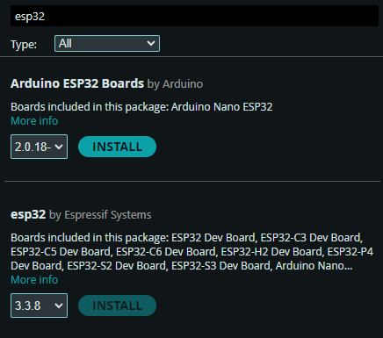

Libraries to install:
ESP Async WebServer by ESP32Async (currently version 3.11.0)
Async TCP by ESP32Async (currently version 3.4.10).

